Lab 9: Acitivity Diagram

Objective
In this lab students will learn how to construct activity diagram in MS Visio.
Activity Diagram
- The purpose of the activity diagram is to model the procedural flow of actions that are part of a larger activity.
- In projects in which use cases are present, activity diagrams can model a specific use case at a more detailed level. However, activity diagrams can be used independently of use cases for modeling a business-level function, such as buying a concert ticket or registering for a college class. Activity diagrams can also be used to model system-level functions, such as how a ticket reservation data mart populates a corporate sales system's data warehouse.
For further details, consult the manual given with this lab handout.
Example:
The purpose of the Open Access Insurance System is to provide automotive insurance to car owners. Initially, prospective customers fill out an insurance application, which provides information about the customer and his or her vehicles. This information is sent to an agent, who sends it to various insurance companies to get quotes for insurance. When the responses return, the agent then determines the best policy for the type and level of coverage desired and gives the customer a copy of the insurance policy proposal and quote.
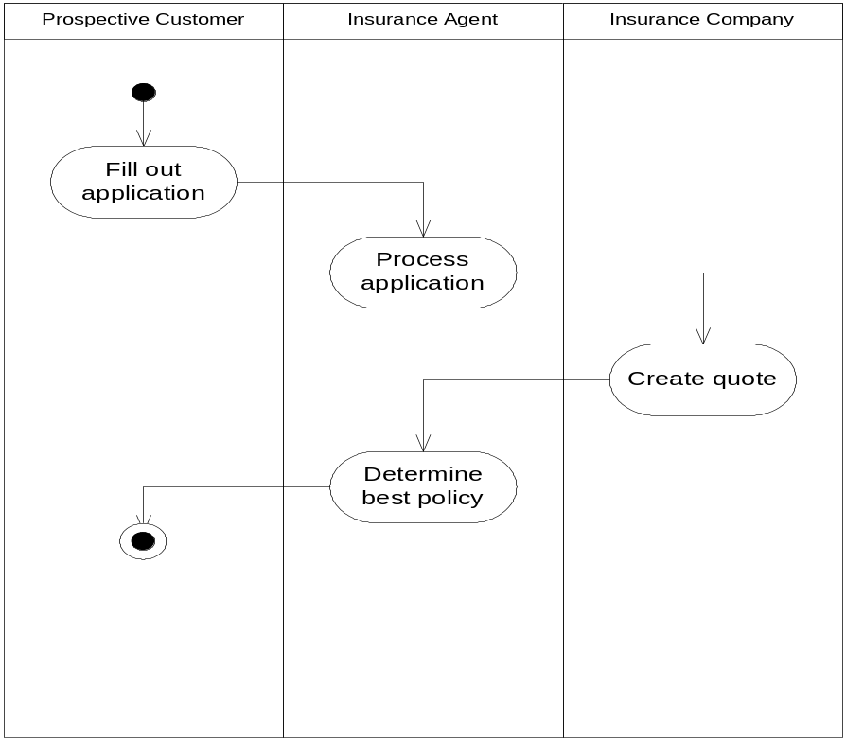

How to Create Activity Diagram:
- Go to File→New→Software & Database→UML Model Diagram.
- Select UML Activity stencil from Shapes Menu.
- If you want to indicate responsibility in the activity diagram, drag a Swimlane shape onto the page for each class, person, or organizational unit you want to represent.
Create swimlanes in an activity diagram:
  - In an activity diagram, drag a Swimlane shape onto the drawing page.
  - Double-click the shape to add a name and other property values.
  - Repeat steps a, b until you've added all the partitions or organizational units you need.
  - Drag the side selection handles on the Swimlane shapes to make the lanes the size you want.
  - Drag State, Action State, Object In State and Signal Receipt or Signal Send shapes into the areas defined by the swimlanes and connect them using Control Flow and Object Flow shapes.
- Drag an Action State or State shape onto the drawing page for each action or activity state you want to represent. Use the Initial State and Final State shapes to represent initial and final pseudo states.
- Connect Control Flow shapes to State shapes to indicate the change from one state to another.
Indicate the flow of control in an activity diagram:
  - In an activity diagram, drag a Control Flow shape onto the drawing page.
  - Glue the Control Flow shape endpoint (without the arrowhead) to a connection point on the source Action State or State shape.
  - Glue the Control Flow shape endpoint (with an arrowhead) to a connection point on the destination Action State or State shape.
  - Double-click the Control Flow shape to add a transition string, including an event (event: An occurrence in Visio, such as a change to a shape formula or the deletion of a page.), guard condition, action expression, and more.
- Use the complex transition shapes, Transition (Fork) or Transition (Join), to represent the forking of one action state into multiple parallel states, or the synchronization of multiple action states into one state.
- Double-click any shape to open its UML Properties dialog box where you can add a name, transition string etc.
- Save the diagram.
Task
Consider the online shopping portal case study given in previous lab. Draw an activity diagram for the scenario of a customer purchasing a book from this shopping portal.
Submission
You have to submit this lab task within lab timings.

